Vermot-Desroches Matthias

Rapport de séance n°2

During this session, I made CAD models for the wooden model of the robot:

Firstly, I drew a sketch of the wooden structure:

Here, you can see that we will need two wooden plate and around 6 wooden joint made with the cutting machine. After speaking with Mr Masson, we decide that we will use this sketch as a base for the CAD model.

After that, I realized the CAD models :

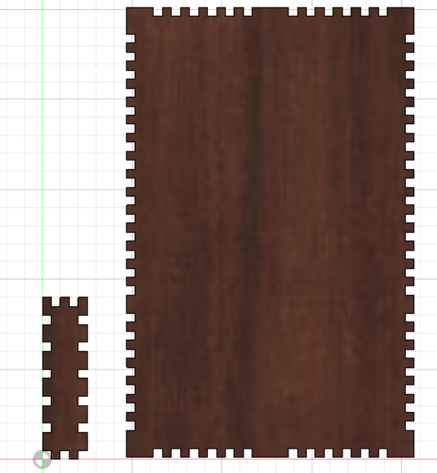

On the left, you can see the joint model and the plate model on the right. The tooth added on every side of the model are there to facilitate the link between the plate and the joint with the addition of some glue. I chose to use 5mm wood as material.

Then, I exported the files in dxf format in order to have svg files.

I only had time to make one try on the cutting machine:

The cut didn’t go through the wood, so I will need to redo the cut until it goes through and repeat the process for the joint and the support piece for the motor.